STUDENT COVER LETTER
WITH NO WORK EXPERIENCE
07098 765 432 | james.ng@gmail.com | 7 University Road, Luton, LU1 1AA
linkedin.com/in/yourname
28 December 2023
Jane Brooks
Fashion Fanatic
12 Barry Street
Luton
LU1 1AR
07132 465 798

Dear Ms Brooks,

When I saw Fashion Fanatic’s advert seeking a Part-Time Retail Associate, I just had to apply. As an undergraduate student pursuing a Business Administration degree and a dream of one day opening my own retail store, I believe I am an ideal fit for your open role.

During my academic journey, I have consistently demonstrated my commitment to acquiring the skills necessary for a successful career in retail. Through various class projects and coursework, I have developed a deep understanding of retail management, consumer behavior, and marketing strategies. These experiences have not only provided me with theoretical knowledge but have also honed my practical problem-solving abilities, which I believe are essential in a fast-paced industry like fashion retail.

One project that I am particularly proud of is my analysis of consumer preferences and purchasing behavior within the fashion industry. This project allowed me to apply market research techniques to gain insights into customer trends and preferences. I believe that the analytical skills I acquired through this project, combined with my passion for staying updated with the latest fashion trends, will enable me to excel at Fashion Fanatic.

I look forward to the possibility of discussing how my skills and experiences align with your company's goals during an interview. You can reach me at 07098 765 432 or james.ng@gmail.com to schedule a suitable time.

Thank you for considering my application.

Yours sincerely,

James Ng


Dear Reader,

Our goal at CV Genius is to provide you with the resources you need to get the job you want, and having a professional-looking CV is an essential part of that mission.

That’s why each one of our CV templates is carefully created to make your application look polished and easy to read. Additionally, our templates are designed to help your CV get past the Applicant Tracking System software that many large employers use to scan through applicants.

However, writing an impressive CV isn’t only about the template you use. Make sure your CV also highlights your qualifications, skills, and experience by using our free resources and reading our articles written by certified career coaches:
- How to write a CV
- CV layout
- CV examples by industry
- CV maker

After you’ve finished writing your CV, download a matching cover letter template and write a cover letter tailored to the position you’re applying for to give your job application an extra boost.

Here are some of our most helpful cover letter resources to help you accomplish that:
- Cover letter builder
- Cover letter examples
- How to write a cover letter
- Cover letter format

Best regards,

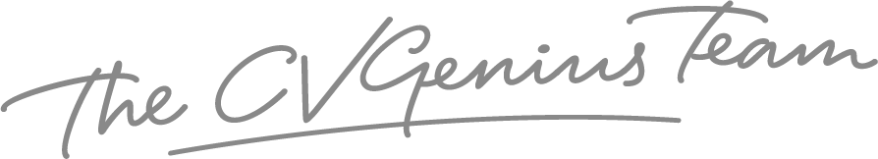

IMPORTANT: To delete this page, right-click on the page and click “Delete Rows”

