
SALES EXECUTIVE CV EXAMPLE
by CV Genius
T | 07123 456 789 |  | Career Summary  Results-driven sales executive with 8 years of experience in sales strategies, customer relations, and product promotion. Track record of securing new clients and mentoring high-performing teams. Possess strong interpersonal skills and am eager to use my background in customer advocacy to boost sales and support the long-term expansion of [Company Name].
E | your.name@gmail.com
A | 51 Kings Road, Loughborough, LE11 1AH
L | linkedin.com/in/yourname
Work Experience
Sales Executive, The Access Group |  |  |  | Loughborough | Jan 20XX–Present
- Oversee numerous sales-based operations, including bid development, contract negotiations, and strategic partnerships with key decision-makers and senior executives
- Represent the business at 47 trade events to boost exposure and acquire market share
- Attend monthly meetings to discuss new strategies and upcoming revenue estimates based on client orders
Business Development Specialist, Smith & Sterling LTD |  |  |  | Bradford | Sep 20XX–Dec 20XX
- Generated new business opportunities through targeted outreach, cold calling, and LinkedIn prospecting, securing high-value meetings for the senior sales team
- Managed and nurtured early-stage leads in the CRM, ensuring a healthy and consistent sales pipeline
Senior Sales Representative, Relish Sales |  |  |  | Leeds | Jul 20XX–Aug 20XX
- Took ownership of the full sales cycle from prospecting to closing deals with SMEs, achieving quarterly revenue targets consistently
- Built strong client relationships, leading to a 28% increase in repeat business year-on-year
Education
Leeds Beckett University, Leeds |  |  |  | Sep 20XX–Jun 20XX
BA (Hons) Business Management — Upper Second-Class Honours (2:1)
Relevant Modules: Business Accounting, Economics, Marketing Principles, Human Resource Management
Additional Skills
Sales operations • Product promotion • Marketing • Negotiation • Customer service • Team leadership • Critical thinking • Problem solving


Dear Reader,

Our goal at CV Genius is to provide you with the resources you need to get the job you want, and having a professional-looking CV is an essential part of that mission.

That’s why each one of our CV templates is carefully created to make your application look polished and easy to read. Additionally, our templates are designed to help your CV get past the Applicant Tracking System software that many large employers use to scan through applicants.

However, writing an impressive CV isn’t only about the template you use. Make sure your CV also highlights your qualifications, skills, and experience by using our free resources and reading our articles written by certified career coaches:
- How to write a CV
- CV layout
- CV examples by industry
- CV maker

After you’ve finished writing your CV, download a matching cover letter template and write a cover letter tailored to the position you’re applying for to give your job application an extra boost.

Here are some of our most helpful cover letter resources to help you accomplish that:
- Cover letter builder
- Cover letter examples
- How to write a cover letter
- Cover letter format

Best regards,

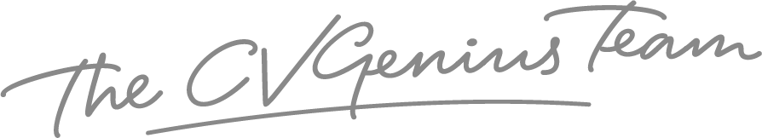

IMPORTANT: To delete the this page, right-click on the page and click “Delete Rows”

