 |  | INFO
MEDICAL STUDENT CV  Example by CV Genius |  | Phone  07123 456 789 |  | Email  your.name@email.com
 |  | Location  34 Royal Court Street,  Edinburgh, EH99 9ZZ |  | LinkedIn  linkedin.com/in/your.name

PERSONAL STATEMENT

Committed medical student with proven clinical exposure through rotations in internal medicine and paediatrics, gaining hands-on experience in patient assessment, care planning, and health education. Skilled at building trust with patients and families through clear communication and empathy. Seeking a position at [Hospital Name] to further develop clinical expertise and deliver high-quality patient care.

CLINICAL ROTATIONS

Internal Medicine

Lincoln County Hospital — January 20XX–March 20XX, Peterborough
- Conducted patient histories and physical examinations under supervision, contributing to diagnostic discussions and treatment planning
- Monitored inpatients, reviewed lab results, and presented cases during ward rounds
- Gained experience in managing chronic illnesses such as diabetes, hypertension, and respiratory disease

Paediatrics

Nottingham Children’s Hospital — October 20XX–December 20XX, Nottingham
- Assisted in outpatient clinics and inpatient care, observing growth, development, and vaccination schedules
- Supported the paediatric team during emergency admissions, learning acute assessment skills
- Developed strong communication skills by explaining treatments to parents and engaging with young patients

EDUCATION

MBBS (Hons) Medicine and Surgery, (Distinction), University of Birmingham, 20XX

KEY SKILLS
- Clinical examination
- Electronic medical records management
- Basic life support (BLS)
- Diagnostic Procedures


Dear Reader,

Our goal at CV Genius is to provide you with the resources you need to get the job you want, and having a professional-looking CV is an essential part of that mission.

That’s why each one of our CV templates is carefully created to make your application look polished and easy to read. Additionally, our templates are designed to help your CV get past the Applicant Tracking System software that many large employers use to scan through applicants.

However, writing an impressive CV isn’t only about the template you use. Make sure your CV also highlights your qualifications, skills, and experience by using our free resources and reading our articles written by certified career coaches:
- How to write a CV
- CV layout
- CV examples by industry
- CV maker

After you’ve finished writing your CV, download a matching cover letter template and write a cover letter tailored to the position you’re applying for to give your job application an extra boost.

Here are some of our most helpful cover letter resources to help you accomplish that:
- Cover letter builder
- Cover letter examples
- How to write a cover letter
- Cover letter format

Best regards,

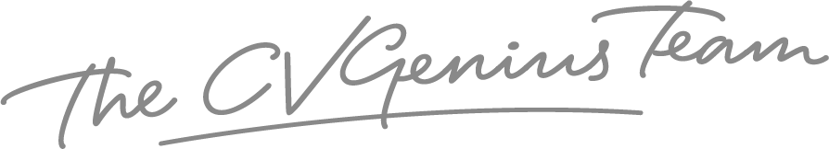

IMPORTANT: To delete this page, right-click on the page and click “Delete Rows”

