LIFEGUARD CV  Example by CV Genius |  | Address: | 38 Fir Road, Bangor, LL14 9EG
 |  | Phone: | 05911 135476
 |  | Email: | your.name@gmail.com
Personal Statement
Reliable Lifeguard with 3+ years of experience, a strong swimming ability, and a passion for ensuring water safety. Skilled in pool surveillance, emergency response, and providing excellent customer service to swimmers of all ages and abilities. Team-oriented with well-developed interpersonal skills and a flexible approach to working in a fast-paced leisure environment. Seeking to join Eastwood Leisure Centre as a Lifeguard, bringing a strong commitment to safety and customer experience.
Work Experience
Forest Hill Leisure Centre, London
Lifeguard, December 20XX–present
- Supervise pool areas to ensure safety of 100+ guests per day
- Perform rescues and administer first aid/CPR when required
- Engage with customers, ensuring a safe and welcoming environment
- Enforce pool regulations and educate visitors on water safety
- Support the wider leisure centre team with operational tasks
Everyone Active, Maidenhead
Assistant Lifeguard, May 20XX–November 20XX
- Assisted lifeguards in monitoring swimmers and maintaining a safe environment
- Provided customer service and responded to guest queries
- Helped maintain cleanliness and organisation of the pool area
- Completed in-house training on emergency procedures and water safety
Education & Certifications
A Levels – Completed: 20XX
Sydenham Sixth Form College
- History (A)
- Business Studies (B)
- Psychology (C)

National Pool Lifeguard Qualification – Certified: 20XX
Royal Life Saving Society UK

First Aid at Work Certification – Certified: 20XX
St John Ambulance

Key Skills
- Water safety and rescue procedures  - Strong swimming ability  - Emergency response and first aid  - Customer service and communication | - Team collaboration  - Adaptability  - Enforcing safety rules and pool regulations  - Fitness and endurance



Dear Reader,

Our goal at CV Genius is to provide you with the resources you need to get the job you want, and having a professional-looking CV is an essential part of that mission.

That’s why each one of our CV templates is carefully created to make your application look polished and easy to read. Additionally, our templates are designed to help your CV get past the Applicant Tracking System software that many large employers use to scan through applicants.

However, writing an impressive CV isn’t only about the template you use. Make sure your CV also highlights your qualifications, skills, and experience by using our free resources and reading our articles written by certified career coaches:
- How to write a CV
- CV layout
- CV examples by industry
- CV maker

After you’ve finished writing your CV, download a matching cover letter template and write a cover letter tailored to the position you’re applying for to give your job application an extra boost.

Here are some of our most helpful cover letter resources to help you accomplish that:
- Cover letter builder
- Cover letter examples
- How to write a cover letter
- Cover letter format

Best regards,

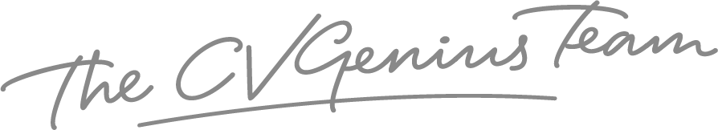

IMPORTANT: To delete this page, right-click on the page and click “Delete Rows”

