
GRADUATE COVER LETTER EXAMPLE
FROM CV GENIUS
T | 07912 345 854
E | tim.bezy@gmail.com
A | York, YO1 0SG
L | linkedin.com/in/tim.bezy

29 November 2023

Megan O’Leary
MetaMark
43 Masons Circle
York
YO1 0SP
07034 285 922
jennifer.oleary@harborough.co.uk

Dear Ms O’Leary,

I am writing to express my strong interest in the Administrative Assistant position at MetaMark posted on your website. As a recent graduate with a Bachelor's degree in Professional Administration, I am excited about the opportunity to contribute my skills, knowledge, and enthusiasm to support the growth and success of MetaMark.

What truly sets me apart as a candidate for this position is my dedication to excellence in every task I undertake. I am highly organised, meticulous, and possess exceptional time management skills. Additionally, my proficiency in Microsoft Office Suite, including Word, Excel, and PowerPoint, allows me to handle various administrative tasks efficiently. I am confident in my ability to assist your team in maintaining a streamlined and efficient office.

I am also a proactive problem solver with a strong commitment to providing exceptional customer service. My experience working part-time as a receptionist during my studies allowed me to hone my interpersonal skills and interact with a diverse range of individuals effectively. I am confident in my ability to represent MetaMark Inc. with professionalism and courtesy in all interactions, both internal and external.

Thank you for considering my application. I look forward to the opportunity to discuss my candidacy further and explore how I can contribute to the continued success of MetaMark. You can reach me on 07912 345 854 or at tim.bezy@gmail.com.

Yours sincerely,

Tim Bezy


Dear Reader,

Our goal at CV Genius is to provide you with the resources you need to get the job you want, and having a professional-looking CV is an essential part of that mission.

That’s why each one of our CV templates is carefully created to make your application look polished and easy to read. Additionally, our templates are designed to help your CV get past the Applicant Tracking System software that many large employers use to scan through applicants.

However, writing an impressive CV isn’t only about the template you use. Make sure your CV also highlights your qualifications, skills, and experience by using our free resources and reading our articles written by certified career coaches:
- How to write a CV
- CV layout
- CV examples by industry
- CV maker

After you’ve finished writing your CV, download a matching cover letter template and write a cover letter tailored to the position you’re applying for to give your job application an extra boost.

Here are some of our most helpful cover letter resources to help you accomplish that:
- Cover letter builder
- Cover letter examples
- How to write a cover letter
- Cover letter format

Best regards,

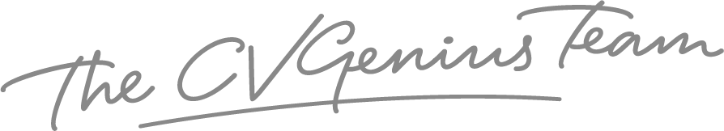

IMPORTANT: To delete this page, right-click on the page and click “Delete Rows”

