EXECUTIVE ASSISTANT CV
Example by CV Genius




linkedin.com/in/your-name
21 Springhill Street, London, N39 6CU
your.email@gmail.com
07123 456 789
CV SUMMARY
Highly organised and efficient Executive Assistant with 5+ years of experience providing comprehensive support to senior executives at Unilever and Deloitte in London. Adept at managing complex schedules, coordinating international travel, and streamlining internal processes to enhance productivity. Ready to bring my expertise in administrative tasks, project coordination, and event planning to [Company Name].
WORK EXPERIENCE
UNILEVER, London
Executive Assistant May 20XX—Present
- Manage complex calendars for 3 senior executives, reducing scheduling conflicts by 10% through proactive planning and coordination
- Organise international travel arrangements for 14 business trips annually, achieving a 20% reduction in travel expenses through meticulous research and negotiation
- Implemented a new digital filing system, improving document retrieval times by 15%
- Coordinated 6 corporate events, including board meetings and annual staff retreats, seamlessly facilitating services for 100+ attendees
DELOITTE, London
Secretary January 20XX–April 20XX
- Supported a team of 10 in the marketing department, handling all administrative duties
- Drafted and proofread internal and external communications, ensuring accuracy and professionalism
- Managed the department's budget, overseeing expenses and contributing to a 13% cost saving through effective resource allocation
- Streamlined communication by implementing an internal messaging system, reducing response times and improving interdepartmental collaboration
EDUCATION
BA in Liberal Arts, Manchester  University of Manchester 20XX–20XX |  |  |  |  |  | (2:1)
KEY SKILLS
- Project management (Jira, Asana) |  |  |  |  | - Fluent Spanish


Dear Reader,

Our goal at CV Genius is to provide you with the resources you need to get the job you want, and having a professional-looking CV is an essential part of that mission.

That’s why each one of our CV templates is carefully created to make your application look polished and easy to read. Additionally, our templates are designed to help your CV get past the Applicant Tracking System software that many large employers use to scan through applicants.

However, writing an impressive CV isn’t only about the template you use. Make sure your CV also highlights your qualifications, skills, and experience by using our free resources and reading our articles written by certified career coaches:
- How to write a CV
- CV layout
- CV examples by industry
- CV maker

After you’ve finished writing your CV, download a matching cover letter template and write a cover letter tailored to the position you’re applying for to give your job application an extra boost.

Here are some of our most helpful cover letter resources to help you accomplish that:
- Cover letter builder
- Cover letter examples
- How to write a cover letter
- Cover letter format

Best regards,

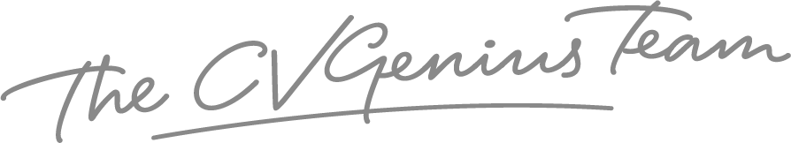

IMPORTANT: To delete this page, right-click on the page and click “Delete Rows”

